R&C Cell_Workshop-Seminars(Jul-2023_Jun-2024)

I. Research Paper Writing Workshop:

R&C Cell conducted Research Paper Writing workshop on 28th July 2023 at BMSIT&M for Ph.D. Research Scholars and Faculty Members of BMSIT&M.
Objective of the Event: In today's academic context, there is consistent demand for academicians to publish good-quality research papers. This requirement is institutionalized and laid down by the statutory and regulatory bodies. The strategic plans by educational institutions to manage research and collaboration have become the main stage for research. Having these
parameters and demands in mind, the objective of this session "Think before you ink - Research paper writing" is to demystify what constitutes a good research paper and overview the pleasures and challenges of writing a research paper. This session will serve as a platform and practical guide to the art of writing research papers.
Speakers:
Morning Session: 10.00 am to 12.30 p.m. | Afternoon Session: 2.00 pm to 4.30 pm
Dr. Rajkumar Elagiri Ramalingam  Apex Semiconductor - AI Engineer | Prof. S.K. Nataraj  Centre for Nano and Material Sciences  (CNMS), Jain University, Bengaluru.

No. of Participants: Research Scholars-33, Faculty Members: 30 and Students-40 = Total:103.

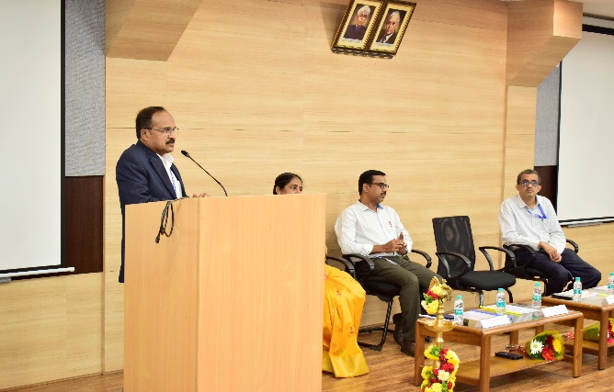
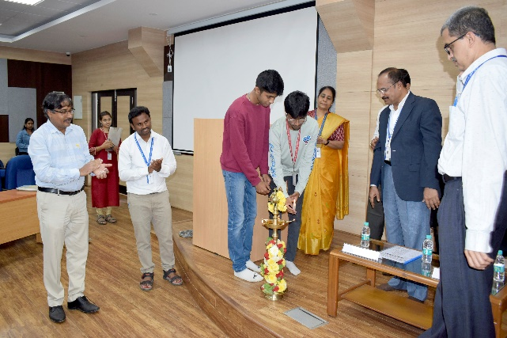

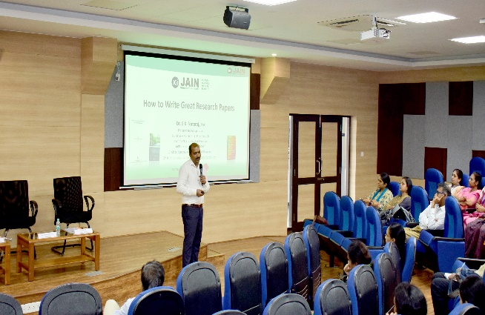
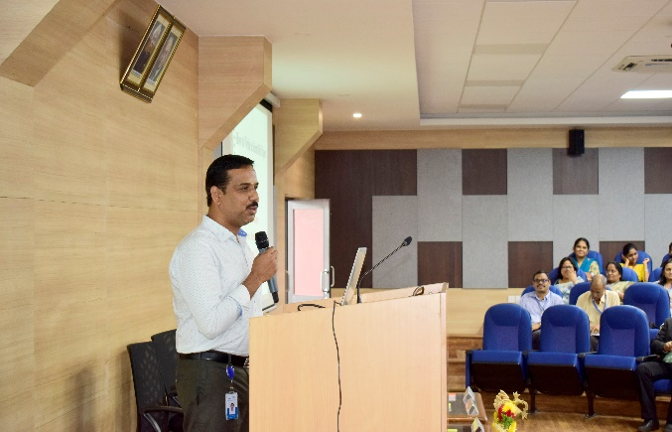

II. One Day Workshop on NVIDIA DGX A100 Server: R&C Cell conducted the One Day Workshop on “NVIDIA DGX A100 Server to faculty members of ECE, ETE, CV, ME and EEE on 7.12.2023. 6 faculty members attended and benefited from the workshop and the main points coved in the workshop.
- Introduction to NVIDIA DGX100 server
- Applications areas of NVIDIA
- Access NVIDIA DGX100
- NVIDIA DGX100 Server with features and setup
- NVIDIA server permeance analysis
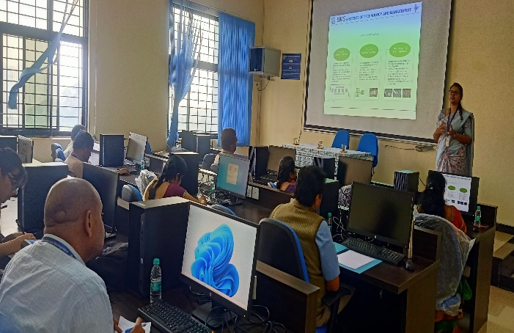
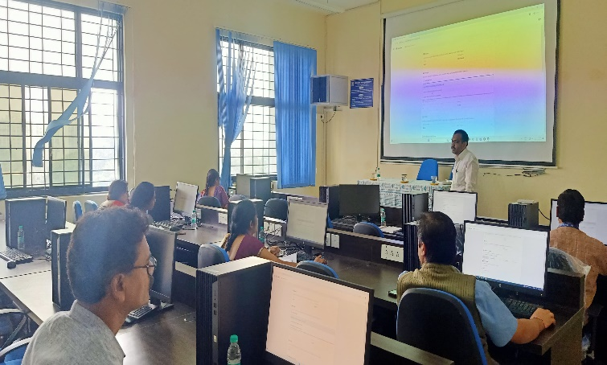
- Job opportunities.

* * * * *

